КЫРГЫЗСКИЙ ТЕХНИЧЕСКИЙ УНИВЕРСИТЕТ им. И. Раззакова

ФАКУЛЬТЕТ ИНФОРМАЦИОННЫХ ТЕХНОЛОГИЙ

Кафедра «ПРОГРАММНОЕ ОБЕСПЕЧЕНИЕ КОМПЬЮТЕРНЫХ

СИСТЕМ»

Дисциплина

Методы оптимизации

Отчет

по практической работе №1

«Метод поразрядного приближения»

Выполнил: студент группы ПИ-1-16

Абакиров Нурсултан

Проверил:

кандидат технических наук, профессор

Тен Иосиф Григорьевич

Оглавление

Раздел №1 Наименование работы 3

Раздел №2 Спецификация проблемы 3

Раздел №3 Спецификация метода 3

Раздел №4 Стадии проектирования системы 4

Раздел №5 Документирования этапов проектирования интерфейсной формы системы 6

Раздел №6 Стадии конструирования ПО 8

Раздел №7 Тестирование 13

# Раздел №1 Наименование работы

Нахождение экстремумов целевой функции методом Поразрядного приближения – Pocket Search Method

# Раздел №2 Спецификация проблемы

Destination/assignment of the algorithm:

To solve the one-dimensional optimization problem $extr f\left(x\right) x∈R^{1}$

using Pocket Search Method and given single an initial approximation x(0) of the searching variable value, and given an initial step size H(0), and given any significance value of digit position R with a required error tolerance tol.

# Раздел №3 Спецификация метода

|  |  |
| --- | --- |
| Mathematical Description of Algorithm of the PSM | Computational Description of Algorithm of the PSM |
| |IF fk >= fk-1 /*Pocket Search Method to find a ***minimum*** */  | |THEN  | | |IF |hk| <= ε/R  | | | |THEN hk+1 = hk; xk+1 = xk; fk+1 = fk;  | | | |ELSE hk+1 = – hk/R; xk+1 = xk+ hk+1; fk+1 = f(xk+1);  | | |endIF  | |ELSE hk+1 = hk; xk+1 = xk+ hk+1; fk+1 = f(xk+1);  |endIF  for k=1, 2, …; | **INPUT** {X0; Epsilon; H0; R; Max; f(X);}  **Body of algorithm**  YF0: = f (X0);  H1: = H0;  X1: = X0 + H1;  YF1: = f(X1);  K:=0;  |WHILE K < Max DO  | K: = K+1;  | |IF YF1 >= YF0 /* Pocket Search Method to find a ***minimum* */**  | | |THEN  | | | |IF abs(H0) < (Epsilon/R)  | | | | |THEN DO H1: = H0; X1: = X0; YF1: = YF0; END;  | | | | |ELSE DO H1: = – (H0/R); H0: = H1;  | | | | X0: = X1; YF0: = YF1;  | | | | X1: = X0 + H1; YF1: = f(X1); END;  | | | |endIF  | | |ELSE DO H1: = H0; X0: = X1; YF0: = YF1;  | | X1: = X0 + H1; YF1: = f(X1); END;  | |endIF;  |endWHILE;  **OUTPUT**  PRINT ‘The optimum solution x* equal’ X1  PRINT ‘The optimum solution was found with the desired tolerance’ Epsilon  PRINT ‘The minimum of objective function f(x*) is’ YF1  PRINT ‘The accuracy is ±‘ Epsilon |
| x0 – Initial approximation of the solution;  h0 – Initial Increment (Initial Step-size of search);  ε – Tolerance;  R – Adjustable parameter of the method (Significance of Digit Position);  fk = f(xk) – objective function at point xk. | X0 – Initial approximation of the solution;  H0 – Initial Increment (Initial Step-size of search);  Epsilon – Tolerance;  R – Adjustable parameter of the method (Significance of Digit Position);  Max – Limit number of iterations. |

# Раздел №4 Стадии проектирования системы

1. Разработка блок-схемы Pocket Search Method:





1. Разработка пользовательского интерфейса.

Форма для взаимодействия пользователя с программой представлена ниже:



# Раздел №5 Документирования этапов проектирования интерфейсной формы системы

1. Документирование процесса задания свойств элементов интерфейсной формы системы



1. Таблица 1: Настройки элементов управления интерфейсной формы системы

|  |  |  |  |
| --- | --- | --- | --- |
| **Number of control** | **Control** | **Property** | **Setting** |
| 1 | Label | Appearance (Text) | Function f(x): |
| Design (Name) | Label1 |
| 2 | Label | Appearance (Text) | Initial point to search: |
| Design (Name) | Label2 |
| 3 | Label | Appearance (Text) | Initial step size: |
| Design (Name) | Label3 |
| 4 | Label | Appearance (Text) | Decreasing rate of the step: |
| Design (Name) | Label4 |
| 5 | Label | Appearance (Text) | Tolerance: |
| Design (Name) | Label5 |
| 6 | Label | Appearance (Text) | Limit of iterations: |
| Design (Name) | Label6 |
| 7 | Label | Appearance (Text) | X1: |
| Design (Name) | Label7 |
| 8 | Label | Appearance (Text) | f(X1): |
| Design (Name) | Label8 |
| 9 | Label | Appearance (Text) | Number Of Iterations: |
| Design (Name) | Label9 |
| 10 | Label | Appearance (Text) | Elapsed time (in seconds): |
| Design (Name) | Label10 |
| 11 | Label | Appearance (Text) | Final inaccuracy: |
| Design (Name) | Label11 |
| 12 | Label | Appearance (Text) | “” |
| Design (Name) | result |
| 13 | Textbox | Appearance (Text) | x^2-4*sin(x) |
| Design (Name) | fx |
| 14 | Textbox | Appearance (Text) | -10 |
| Design (Name) | x0 |
| 15 | Textbox | Appearance (Text) | 1 |
| Design (Name) | H0 |
| 16 | Textbox | Appearance (Text) | 10 |
| Design (Name) | R |
| 17 | Textbox | Appearance (Text) | 1E-14 |
| Design (Name) | Tolerance |
| 18 | Textbox | Appearance (Text) | 100 |
| Design (Name) | Limit |
| 19 | Textbox | Appearance (Text) | extremum of function |
| Behavior (ReadOnly) | True |
| Design (Name) | x1 |
| 20 | Textbox | Appearance (Text) | F(x1) |
| Behavior (ReadOnly) | True |
| Design (Name) | yf1 |
| 21 | Textbox | Appearance (Text) | amount of iterations |
| Behavior (ReadOnly) | True |
| Design (Name) | iter |
| 22 | Textbox | Appearance (Text) | elapsed time |
| Behavior (ReadOnly) | True |
| Design (Name) | time |
| 23 | Textbox | Appearance (Text) | H |
| Behavior (ReadOnly) | True |
| Design (Name) | H1 |
| 24 | RadioButton | Appearance(Text) | Min |
| Design(Name) | min |
| 25 | RadioButton | Appearance(Text) | Max |
| Design(Name) | max |
| 26 | Button | Appearance(Text) | Run Pocket Search Method |
| Design(Name) | button1 |
| 27 | Button | Appearance(Text) | clear |
| Design(Name) | button2 |
| 28 | ProgressBar | Design(Name) | progressBar1 |

# Раздел №6 Стадии конструирования ПО

1. Код программы на SWIFT, ассоциированный с интерфейсной формой и реализует логику Golden Section по поиску корня нелинейного уравнения “ViewController.swift” 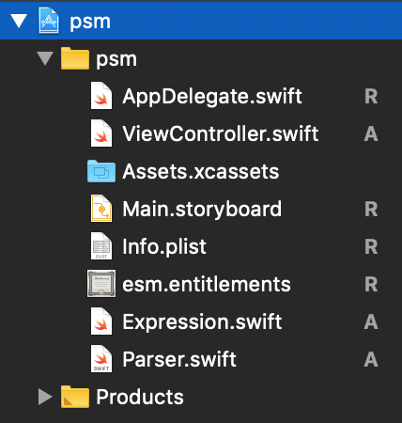

//

// ViewController.swift

// esm

//

// Created by user on 12/8/18.

// Copyright © 2018 user. All rights reserved.

//

import Cocoa

class ViewController: NSViewController {

@IBOutlet weak var functionInput: NSTextField!

@IBOutlet weak var x0Input: NSTextField!

@IBOutlet weak var toleranceInput: NSTextField!

@IBOutlet weak var kMaxInput: NSTextField!

@IBOutlet weak var tMaxInput: NSTextField!

@IBOutlet weak var minInput: NSButton!

@IBOutlet weak var maxInput: NSButton!

@IBOutlet weak var functionsInput: NSComboBoxCell!

@IBOutlet weak var rInput: NSTextField!

@IBOutlet weak var hInput: NSTextField!

@IBOutlet weak var x1Output: NSTextField!

@IBOutlet weak var yf1Output: NSTextField!

@IBOutlet weak var kOutput: NSTextField!

@IBOutlet weak var hOutput: NSTextField!

@IBOutlet weak var elapsedTimeOutput: NSTextField!

@IBOutlet weak var progressBar: NSProgressIndicator!

@IBOutlet weak var messageOutput: NSTextField!

override func viewDidLoad() {

super.viewDidLoad()

// Do any additional setup after loading the view.

}

override var representedObject: Any? {

didSet {

// Update the view, if already loaded.

}

}

@IBAction func maxClicked(_ sender: Any) {

minInput.state = NSControl.StateValue(rawValue: 0)

}

@IBAction func minClicked(_ sender: Any) {

maxInput.state = NSControl.StateValue(rawValue: 0)

}

@IBAction func runBtnClicked(_ sender: Any) {

self.clear()

if !self.isValid() {

return

}

var x0 = x0Input.doubleValue

var x1: Double

let f = Parser(expression: functionsInput.stringValue)

let tol: Double = toleranceInput.doubleValue

var h: Double = hInput.doubleValue

let r: Double = rInput.doubleValue

var kMax: Int = kMaxInput.integerValue

let tMax: Double = tMaxInput.doubleValue

var isMin: Bool

var yf0: Double = f.run(x: x0)

var yf1: Double

var h1 = h

var k: Int = 0

if minInput.state == NSControl.StateValue(rawValue: 1) {

isMin = true

} else {

isMin = false

}

let startTime = Date()

var endTime = NSDate()

var found: Bool = false

var isTimeReached = false

progressBar.doubleValue = 0.0

repeat {

k += 1

progressBar.doubleValue = Double(k * 100 / kMax)

if isMin{

if abs(h) < tol / r {

h1 = h

x1 = x0

yf1 = yf0

found = true

messageOutput.stringValue = "Found minimum of function with a given \ntolerance \(tol)"

} else {

x1 = x0 + h1

yf1 = f.run(x: x1)

if yf1 >= yf0 {

h1 = -h / r

} else {

h1 = h

}

x0 = x1

yf0 = yf1

h = h1

}

} else {

if abs(h) < tol / r {

h1 = h

x1 = x0

yf1 = yf0

found = true

messageOutput.stringValue = "Found maximum of function with a given \ntolerance \(tol)"

} else {

x1 = x0 + h1

yf1 = f.run(x: x1)

if yf1 <= yf0 {

h1 = -h / r

} else {

h1 = h

}

x0 = x1

yf0 = yf1

h = h1

}

}

endTime = NSDate()

if k == kMax {

if self.dialogOKCancel(question: "Continue Search?", text: "Solution was not found in given limit of iterations, add \(kMax) more iterations") {

kMax += kMax

kMaxInput.stringValue = String(kMax)

} else {

messageOutput.stringValue = "Not possible to find solution for given \namount of iterations \(kMax)"

}

}

if endTime.timeIntervalSince(startTime) >= tMax {

isTimeReached = true

messageOutput.stringValue = "Not possible to find solution for given \ntime limit \(tMax)"

}

} while k < kMax && !isTimeReached && !found

if k == 1 && found {

messageOutput.stringValue = "Can't find an extremum or X0 placed in \nthe right-of-solution X*"

self.alertModal(messageText: "Try X0 be lefter and closer to X*", informativeText: "Found not best fit X*")

}

progressBar.doubleValue = 100

x1Output.doubleValue = x1

yf1Output.doubleValue = yf1

kOutput.stringValue = String(k)

hOutput.doubleValue = h1

elapsedTimeOutput.doubleValue = endTime.timeIntervalSince(startTime)

}

@IBAction func clearBntClicked(_ sender: Any) {

self.clear()

}

func clear() {

x1Output.stringValue = ""

yf1Output.stringValue = ""

kOutput.stringValue = ""

hOutput.stringValue = ""

elapsedTimeOutput.stringValue = ""

messageOutput.stringValue = ""

progressBar.doubleValue = 0

}

func setInvalidInput() {

self.alertModal(messageText: "invalid input", informativeText: "")

messageOutput.stringValue = "invalid input"

}

func isValid() -> Bool {

for raw in [functionsInput.stringValue] {

let f = Parser(expression: raw)

do {

_ = try f.check_run(x: 1)

} catch {

self.setInvalidInput()

return false

}

}

for el in [x0Input, hInput, rInput, toleranceInput, kMaxInput, tMaxInput] {

if Double(el!.stringValue) == nil {

self.setInvalidInput()

return false

}

}

return true

}

func alertModal(messageText: String, informativeText: String) {

let alert = NSAlert()

alert.messageText = messageText

alert.informativeText = informativeText

alert.alertStyle = .warning

alert.addButton(withTitle: NSLocalizedString("OK", comment: "OK"))

alert.runModal()

}

func dialogOKCancel(question: String, text: String) -> Bool {

let alert = NSAlert()

alert.messageText = question

alert.informativeText = text

alert.alertStyle = .warning

alert.addButton(withTitle: "OK")

alert.addButton(withTitle: "Cancel")

return alert.runModal() == .alertFirstButtonReturn

}

}

**Подключение библиотечной программы “ Expression ” к программному проекту для выполнения фун**

**кции парсинга**

Шаг №1: Скачать с сайта https://github.com/nicklockwood/Expression/tree/master/Sources

файл парсера [Expression.swift](https://github.com/nicklockwood/Expression/blob/master/Sources/Expression.swift):

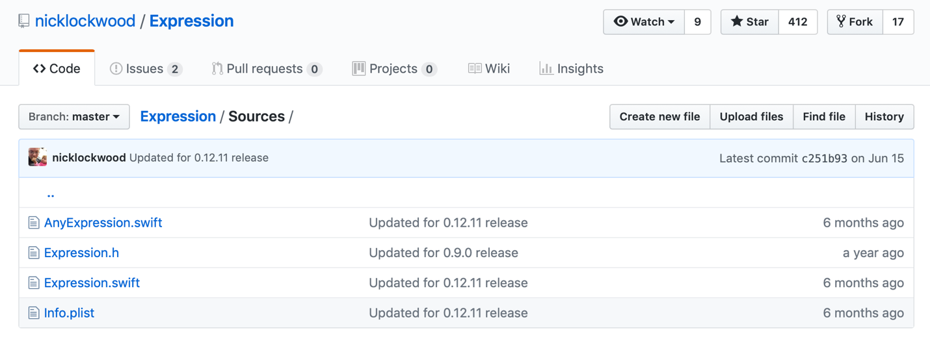

Шаг №2: Вставить скаченный файл в папку проекта:

Шаг №3: Так как парсер не предоставляет полный спектр математических функций, дописываем файл Parser.swift

**import** Foundation

**class** Parser {

**private** **var** expression: Expression

**private** **var** x: Double

**init**(expression: String) {

**self**.x = 0

**self**.expression = Expression("1 + 1")

**self**.expression = Expression(expression, symbols: [

.variable("x"): { **_** **in** **self**.x},

.function("exp", arity: 1): {args **in** exp(args[0])},

.function("log", arity: 1): {args **in** log(args[0])},

])

}

**public** **func** run(x: Double) -> Double {

**self**.x = x

**do** {

**return** **try** **self**.expression.evaluate()

} **catch** {

fatalError()

}

}

}

# Раздел №7 Тестирование

1. Тест №1 функция: x^2-4*sin(x)



Не найдено решение за указанное количество итерации.





Ошибка в выражении функции f(x)



1. Тест №2 функция №2: -x^3-10*x^2+x+10

Минимум:



Максимум:

 